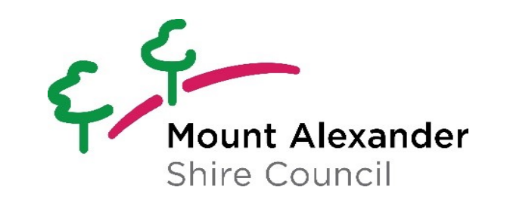

Mount Alexander Shire Middle Years Plan

2023-2026

We acknowledge the Dja Dja Wurrung and the Taungurung as the traditional owners of the lands and waters of the Mount Alexander Shire and recognise all other Indigenous people of the Shire and the vital role that the Traditional Owners play as custodians of the region

Table of Contents
About this Plan 3
Our vision 3
Our focus 3
Why the middle years matter 4
Council’s role 4
Bulortj Children and Youth Network 6
What’s changed since the last Plan? 7
Who did we hear from? 8
Values 8
What’s working 10
Issues 11
Ideas 12
Our priorities 13
Priority Area 1: Happy and included 14
Priority Area 2: Active and outside 15
Priority Area 3: Safe and supported 16
Implementation costs 17
Review and evaluation 17
Risk analysis 17
Appendix 1. Policy context 19
Appendix 2: Mount Alexander Shire Council Child Safe Statement of Commitment 21

About this Plan

This Plan has been developed to support the nearly 800 middle years children aged 8-12 living in Mount Alexander Shire.

We are deeply committed to ensuring our towns and communities are inclusive and welcoming for children and families, and this Plan reinforces Council’s endorsement of the Child Friendly Cities and Communities Charter in 2019.

This Plan has been developed in consultation with middle years children across Mount Alexander Shire. It highlights areas of focus, and the actions we believe are most important here and now. We want this to be a plan that can respond to the emerging needs of our community, our families and our children.

We are grateful to be working alongside our local schools, service providers, clubs and organisations to deliver for our children. And of course, we are always guided and inspired by the middle years kids – in all their diversity – in our Shire.

Our vision

All children aged 8 to 12 years and their families in Mount Alexander Shire are happy, safe, active and connected.

Our focus

Happy and included | Middle years children and families are happy, well-informed, included and ready to transition to high school. | 
Active and outside | Kids have opportunities to be physically active, to care for the environment and connect with Country. | 
Safe and Supported | Middle years children and families are safe and can access the support they need. | 

Why the middle years matter

The middle years of childhood (8-12 years of age) are an important period of individual growth and learning, characterised by rapid physical, cognitive, emotional and social development.

During this time puberty begins, children are finding a sense of self, growing and establishing peer relationships and making the transition from primary to secondary school.

This period of significant change and growth also sees children develop resilience and adaptability, and strategies to manage themselves in different situations.

These transitional years are an important time for establishing the foundations of future wellbeing. Children want to expand their play, to care for the environment and to learn. But they also need the right support to navigate the more complex problems they, and their families face.

Council’s role

In December 2019 Council endorsed the Child Friendly Cities and Communities Charter. This means Council is committed to creating child-friendly towns, spaces and experiences across the Mount Alexander Shire. In addition, the Council Plan 2021-2025 supports a healthy, connected and inclusive community.

- For children 8-12, this looks like accessible and coordinated services, safety regardless of identity or circumstance, mental and physical wellbeing, connection to community and inclusion.
- It also reflects in our efforts to maintain, improve and celebrate our places and spaces for children and families, in harmony with nature.

The Middle Years Plan 2023-2026 will guide how Council, partners, service providers and the community can work together to achieve these outcomes, and more.

Each action states which stakeholder is the responsible organisation for its implementation as well as the role of Council in its delivery. Council’s role has been defined as one of the following:

Lead: Council adopts full responsibility for delivery of the action, due to the action being either internal or at a policy level.

Facilitate: Undertaking a process involving other stakeholders, which will be driven by Council.

Support: Add value to activities that are initiated by, and the responsibility of, other agencies. This may include promotion, in-kind support or providing advice.

Advocate: Using Council’s role in the community to exert influence on external agencies to undertake an action.

Through this Plan, Council will continue to advocate for the services families need locally. While families in Mount Alexander Shire have access to a range of services for their middle years children, demand is growing – particularly for disability and additional needs support (Figure 1).

This Plan is guided by the pillars, objectives and strategies identified in the Council Plan 2021-2025. In particular, we recognise the mission “Working together for a healthy, connected shire”.

Figure 1. Services accessed by families in the past 12 months (2023). Comparison of survey responses from Mount Alexander Shire parents and carers in 2023 and 2020.

Bulortj Children and Youth Network

The Bulortj Children and Youth Network brings together organisations that provide services for 8-24 year olds who reside in the Mount Alexander Shire.

Bulortj, or the Cherry Ballart, is a symbol of cooperation and community. It is still in use today in age-old Djaara ceremonies of cleansing and renewal. Its use draws on the knowledge that, like children in their communities, the Bulortj cannot flourish unless it is attached to another tree. It is a reminder of the importance of cooperation between people if all are to thrive.

The Bulortj Children and Youth Network has been advocating for the needs of young people in the Shire for over a decade. It facilitates the sharing of resources and good practice, and develops and implements strategies to meet the needs of young people in Mount Alexander Shire.

The Network is facilitated by Council and includes the following member organisations:
- Castlemaine Secondary College
- Dhelkaya Health
- Goldfields Library Corporation (Castlemaine Library)
- Nalderun Education Aboriginal Corporation
- Primary schools
- School Focused Youth Service
- Victoria Police
- Goldfields Local Learning and Employment Network
- Anglicare Victoria

A key role of the Network is to act as the steering group for the implementation of the Middle Years Plan.

What’s changed since the last Plan?



Two years of social isolation, remote schooling and pandemic

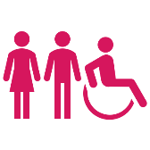
Population growth in Mount Alexander Shire. Although this population growth has been more significant in older age groups, the increasing demand on health services has affected families.



More complex behavioural challenges among children locally.


Rising rates of attention deficit hyperactivity disorder (ADHD) and Autism Spectrum Disorder (ASD).


More families are needing support to find housing locally, with many leaving the Shire to find affordable and secure housing.

Who did we hear from?

This Plan has been developed in close consultation with our community. Most importantly, we listened to our middle years children across our Shire.

This involved:

187 middle years children completing surveys

38 middle years children attending an ideas workshop at Council

95 total survey responses from parents, carers and service providers

Three key informant interviews with school principals

Two reflection workshops with the Bulortj Children and Youth Network

Values

Children in their middle years value their families above all else, followed by friends and art and music. Gaming is increasingly valued among those surveyed – an 18% rise from 2020.

Figure 2. “Most important thing to me” according to 180 middle years children as cited in their 2023 survey responses and compared with 2020 responses.

Parents surveyed indicated health and wellbeing remains the most important consideration for their family, followed by education and social networks (which increased by 16% from 2020). Those valuing local facilities and safety in 2023 also increased markedly from surveyed parents in 2020.

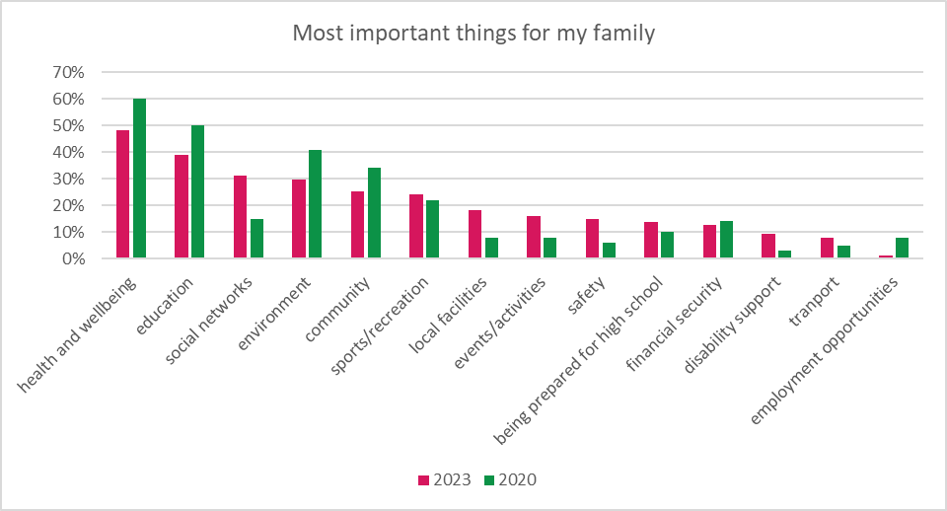
Figure 3. “Most important things for my family” according to Mount Alexander Shire parents and carers surveyed in 2023 and 2020.

What’s working

Middle years children engaged in the consultation for the development of this Plan valued the natural surrounds of the Shire and the size and people of the towns they live in. Since 2020, more kids indicated their appreciation for local pools, food and shops and sport in the Shire.

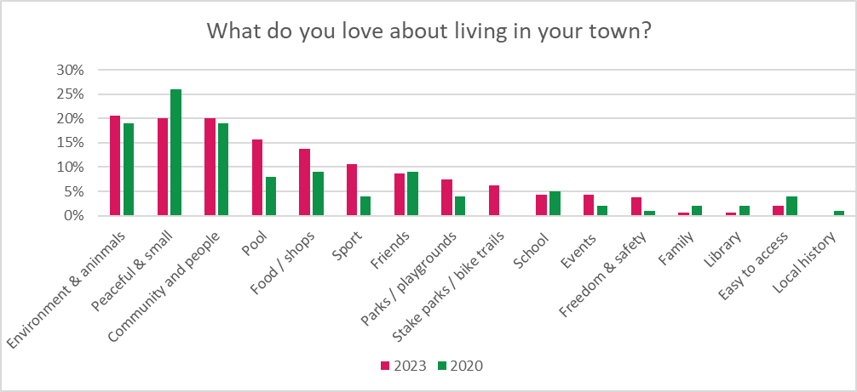
Figure 4. “What do you love about living in your town” according to 180 middle years children as cited in their 2023 and compared with 2020 responses..

Parents and carers of middle years children valued their communities, their lifestyle and local schools – largely consistent with results from 2020.
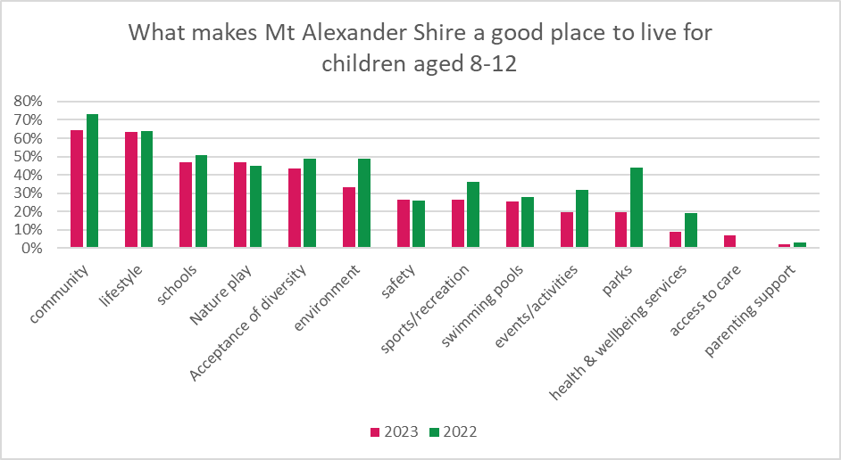Figure 5. “What makes Mount Alexander Shire a good place to live for children” according to Mount Alexander Shire parents and carers surveyed in 2023 and 2020

Issues

We know the pressures on many families have grown in recent years. These are the big issues we heard this Plan needs to address.

 | Impact of COVID-19 pandemic on health, wellbeing and learning. More than half (54%) of parents and carers surveyed reported that their family’s health and wellbeing was impacted or severely impacted by the pandemic. Half (51%) of families reported that their children’s learning was impacted, including 17% who reported it had been severely impacted.
 | Access to local services is challenging. More middle years children are needing support – from neurological disabilities and learning challenges, to social anxieties and housing insecurity. Service providers also noted an increase in rates of non-suicidal self-harm. Wait-lists for specialised services such as child psychologists, speech therapists and occupational therapists are extensive, with many families having to travel and/or pay privately for the support they need.
 | Online safety remains a priority. One in ten children surveyed locally placed a high value on using social media, while over a third (38%) valued gaming. 12% of children surveyed said they worry about being safe online, while 8% said they worry about cyber-bullying.
 | Parents are feeling stressed. Insecure housing and the rising cost of living is putting many local families under pressure. Parental stress impacts children’s learning, emotional regulation and overall wellbeing.
 | Complex and additional needs are becoming more common. One in twenty children are estimated to have ADHD while around one in seventy are autistic. Around a third (31%) of families reported caring for a child with additional needs in 2023 compared to 8.5% in 2020. This means more demands on families, schools and services.
 | Expectations on teachers are rising. Teachers are at the front-line of learning, while also working as key social and wellbeing supports for their students. Placing more demands on local teachers to play a more central role in primary prevention or response to behavioural or neurological challenges is not sustainable.
 | Concerns about the effects of climate change. Children identified ‘the environment’ as their biggest worry and expressed a need for more climate change action.

Ideas

We asked our middle years kids what they would do if they were in charge for a day. Here are some of the responses.

“I would like there to be a wildlife park in Campbell's Creek”

“A kids book club at a library. I would want a tween book club in Castlemaine library on Sunday afternoon.”

“More parks, clean up days, tree planting, another animal park. I love animals.”

“Fix the skate park up.”
“I would make a Minecraft club. Free computers.”

“Plant more TREES in public spaces!!!”

“Build an ice cream shop”

“Create a campaign for collecting as much rubbish as you can…Create posters and make schools do it as well.”

“I'd give a discount to kids so they can buy things and help their families.”

“Cheaper housing.”

Figure 6 summaries the project ideas of a workshop with 38 middle years students at Council.

Our priorities

Kids in the middle years of childhood need and deserve a range of supports and opportunities. Some of these will be to empower kids, some to prevent potential challenges in adolescence and some to respond to challenges here and now. While the following priority areas outlined in this Plan have their own strategies and actions, we understand these are all – directly or indirectly, connected (Figure 7).

Figure 7. Interconnected priority areas and strategies
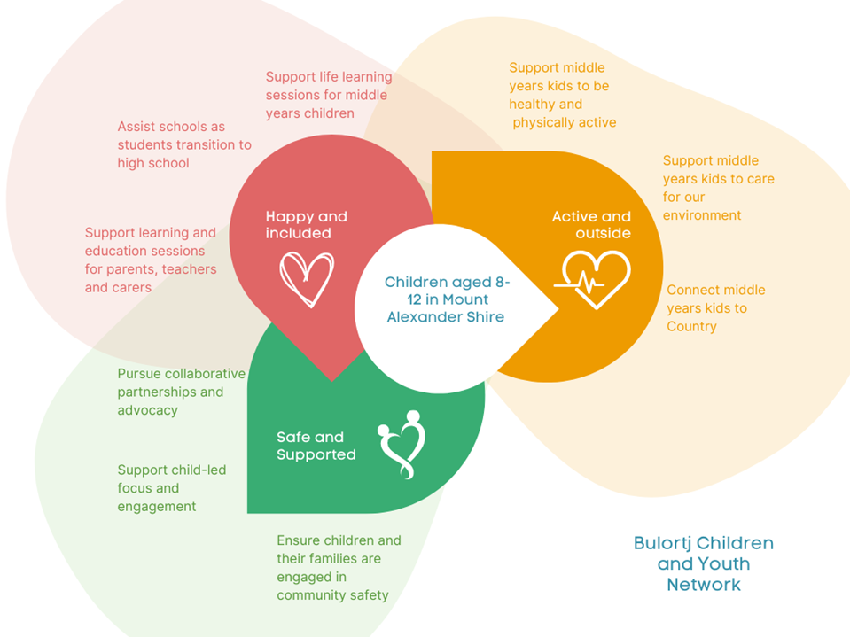

Priority Area 1: Happy and included

Objective: Middle years children and families are happy, well-informed, included and ready to transition to high school.

Strategies | These will include | Responsible stakeholder | Council’s role
1.1 Support wellbeing education sessions for middle years children | 1.1.1  Delivering kids’ programs that respond to known and emerging needs, such as preparation for puberty, mental health, identity, positive masculinity, social skills and online safety | Bulortj Children and Youth Network | Support
 | 1.1.2  Exploring ways to expand the activity program for middle years children at Castlemaine Library | Castlemaine Library | Support
1.2 Support learning and education sessions for parents, carers and teachers | 1.2.1  Coordinating and promoting parental education sessions and programs for our families to improve middle years child wellbeing, safety and family resilience | Bulortj Children and Youth Network | Support
 | 1.2.2  Coordinating the delivery of mental health training for teachers and school staff | Bulortj Children and Youth Network | Facilitate
 | 1.2.3  Supporting training and initiatives that respond to the needs of families with children experiencing additional needs | Bulortj Children and Youth Network | Support
 | 1.2.4  Promoting training for local schools, organisations and service providers to be more inclusive of diverse families | Bulortj Children and Youth Network | Support
1.3 Support students to transition to high school | 1.3.1  Exploring ways to better support students to transition to secondary school, especially those experiencing challenges | Bulortj Children and Youth Network | Support

Priority Area 2: Active and outside

Objective: Kids have opportunities to be physically active, to care for the environment and connect with Country.

Strategies | These will include | Responsible stakeholder | Council’s role
2.1 Support middle years kids to be healthy and physically active | 2.1.1  Exploring ways to increase skate, scoot and cycling opportunities for middle years children and families | Council | Lead
 | 2.1.2  Ensuring the needs of children are considered when upgrading the walking and cycling network around local primary schools | Council | Lead
 | 2.1.3  Ensuring the needs of children are considered when designing playgrounds and play spaces | Council | Lead
 | 2.1.4  Supporting and championing all-abilities access to sport and recreation activities | Council | Facilitate
 | 2.1.5  Exploring ways to support growth and development through access to nutritious food | Bulortj Children and Youth Network | Support
2.2 Support middle years kids to care for our environment | 2.2.1  Increasing opportunities for children to engage in climate change action and implement environmental sustainability practices | Bulortj Children and Youth Network | Facilitate
2.3 Connect middle years kids to Country | 2.3.1  Promote resources that encourage children and families to connect to Djaara Country and Culture | Bulortj Children and Youth Network | Support
2.3 Connect middle years kids to Country | 2.3.2  Continue to support Nalderun Education Aboriginal Corporation to deliver quality educational and cultural programs for First Nations children | Council | Support

Priority Area 3: Safe and supported

Objective: Middle years children and families are safe and can access the support they need.

Strategies | These will include | Responsible stakeholder | Council’s role
3.1 Support child-led focus and engagement | 3.1.1  Ensuring this Plan remains responsive to emerging needs as guided by children | Bulortj Children and Youth Network | Facilitate
3.1 Support child-led focus and engagement | 3.1.2  Building capacity of children to be leaders and advocates for children’s needs | Bulortj Children and Youth Network | Facilitate
3.1 Support child-led focus and engagement | 3.1.3  Developing processes to ensure our middle years children and families are able to provide input into Council’s planning and programs | Council | Lead
3.2 Pursue collaborative partnerships and advocacy | 3.2.1  Facilitating opportunities for schools to identify and share information, data, learning and funding opportunities, events and other initiatives | Council, Local schools | Facilitate
3.2 Pursue collaborative partnerships and advocacy | 3.2.2  Continuing to advocate for an increase in the number of health and wellbeing services available locally for middle years children and their families (e.g. counsellors, psychologists, General Practitioners) | Bulortj Children and Youth Network | Advocate
3.3 Ensure children and their families are engaged in community safety | 3.3.1  Supporting the relationship between the local Police and community, and promoting a better understanding of how we can collaboratively increase community safety | Victoria Police | Support
 | 3.3.2  Continuing to work with our key partners to ensure emergency preparedness and planning specifically considers the needs of our children and their families | Council | Lead

Implementation costs

The implementation of the Mount Alexander Middle Years Plan 2023-26 will be predominantly undertaken with existing Council resources, and through the in-kind and financial support of key stakeholders as required.

External grants and resources will also be explored as and when required.

Review and evaluation

The outcomes in this Plan will take time to achieve. Being both systemic and individualistic in nature, monitoring their progress is crucial to the Plan’s success.

The Bulortj Children and Youth Network, as the Steering Group for the Plan, will be critical to this process. The Network will meet quarterly to review progress, discuss opportunities and set a course for actions.

Regular conversations and forums will ensure that the community and key stakeholders are informed of the Plan’s progress and successes, and that each achievement is acknowledged, shared and celebrated.

This approach will be supported by an annual review process that will allow for actions to remain responsive to new and emerging priorities and needs. Annual statements will also be produced to share the findings of each review and provide an outline of the focus for the following year.

In December 2026, an evaluation of the Plan will be undertaken with learnings and outcomes used to inform the development of future early years planning.

Risk analysis

There are three main risks to delivering this Plan: maintaining engagement and collaboration among stakeholders; identifying appropriate funding for priority actions; and responding to emerging needs or crises. We will seek to manage these risks by:

- Tasking the Bulortj Children and Youth Network with steering the implementation of the Plan, including the regular review and delivery of actions.
- Developing annual implementation plans to identify actions that require external funding and those that can be undertaken within existing funding and through the support of key partners.
- Ensuring stakeholders – including Council – continue to engage middle years children in planning and decision-making.

Appendix 1. Policy context

The development of this Plan has been guided by current data, research and feedback received from our community. It has also been developed within the context of local, State, Federal and international legislation, policies and strategies which has included, but is not limited to the following:

Local | Mount Alexander Shire Council Plan 2021-25  Mount Alexander Municipal Public Health and Wellbeing Plan 2021-25  Mount Alexander Shire Council Child Safe Policy 2022  Mount Alexander Environmental Strategy, 2015-25  Gender Equality Action Plan (GEAP) 2021-2025  Loddon Campaspe Integrated Transport Strategy  Mount Alexander Early Years Plan 2022 - 2026  Mount Alexander Shire Council – Let’s Play 2014-2024: Investing in Play, 2014  Reconciliation Plan 2020 – 2023  Walking and Cycling Strategy 2010-2020  Youth Engagement Charter 2013
State | Middle Years Literacy and Numeracy Support (MYLNS) initiative 2023, Victorian Government  Free from violence: Victoria's strategy to prevent family violence, Victorian Government 2018-21  Charter of Human Rights and Responsibilities Act 2006,  Victorian Government  Child, Youth and Families Act 2005, Victorian Government
Federal | Safe and Supported: the National Framework for Protecting Australia’s Children, Australian Government, 2021-2031  A stronger, fairer Australia: national statement on social inclusion, Australian Government 2009  Shaping our Future: A ten year strategy to ensure a sustainable, high quality children’s education and care workforce, 2022-2031, Education Services Australia
International | Child Friendly Cities Initiative, UNICEF 2009  Convention of the Rights of the Child, United Nations 1989

Appendix 2: Mount Alexander Shire Council Child Safe Statement of Commitment

Mount Alexander Shire Council is committed to the prevention of harm and abuse to children and young people and will work in accordance with the Victorian Child Safe Standards.

We recognise our legal and moral responsibilities in keeping children and young people safe from harm and promoting their best interests. We commit to ensuring that a culture of child safety is embedded into our practices and processes and that all Councillors, employees, volunteers, contractors, agency staff, consultants and students over the age of 18 understand that the safety of children and young people is everybody’s business.

Every child and young person accessing our organisation and its services has the right to feel and be safe.

We have zero tolerance for child abuse and will treat all complaints and allegations seriously and immediately.

We take a risk management approach in line with the Risk Management Policy to minimise or eliminate the potential for child abuse or harm to occur.

We embrace diversity and inclusion and in doing so we recognise that all children and young people, regardless of their gender, race, religious beliefs, age, disability, sexual orientation, family background and social background, have equal rights to protection from abuse.

We commit to the cultural safety of Aboriginal and Torres Strait Islander children and young people and children and young people from culturally and/or linguistically diverse backgrounds, and to the provision of a safe environment for children and young people with a disability, as well as other vulnerable groups of children and young people.

We create environments where all children and young people have a voice and are listened to, their views respected and they contribute to how we plan for, design and develop our services and activities. We are committed to the physical, emotional, psychosocial and cultural wellbeing of all children and young people.

All Councillors, employees, volunteers, contractors, agency staff, consultant and students over the age of 18 have a responsibility to understand and activate their role in preventing, detecting, responding and reporting any suspicions of child abuse to the relevant authorities and in maintaining a child safe culture.

We do not tolerate racism or discrimination and expect that Councillors, employees, volunteers, contractors, agency staff, consultants and students over the age of 18 will act on all incidents of racism.

DARREN FUZZARD

Chief Executive Office

Australian Early Development Census. 2021. Community Profile: Mount Alexander. p.9
Central Victoria Primary Care Partnership. 2020. Infrastructure Victoria Regional Victoria Submission. p.6

